# Hello Raspberry! Experiment

## Introduction

After a programmer retired, he liked calligraphy. One day, he suddenly had an aesthetic mood after a meal, so he prepared the "Four Treasures of the Study", Mao, Ink, Paper, and Research, with Wang Xizhi's demeanor and Yan Zhenqing's attitude. After a moment of contemplation, write down carefully: "Hello world!". Why are programmers so keen on these words? The birth of "Hello world" can be traced back to 1972. The famous researcher Brian Kernighan of Bell Laboratory first used it (program) when writing "Tutorial the Introduction to the Language B". This is the earliest " "Hello" and "word" are used together in computer work. Then, in 1978, he used this sentence pattern "hello, world" again in the C language bible "C programming language", co-authored with Dennis Ritchie, as the first program of the opening ceremony. In this program, the output of "hello, world" is all lowercase, without an exclamation mark, and a comma followed by a space. Since then, "Hello, World" has become a tradition for the world to welcome the outside world. "Hello RaspberryPi!", without exception, became the first program in the tutorial

## connection

Use the power cord to directly power the Raspberry Pi

## C++ program

|  |
| --- |
| #include <stdio.h>  #include <wiringPi.h>  **using** **namespace** std**;**  int main **()**  **{**  printf**(**"Hello RaspberryPi !\n"**);**  **while(**1**);**  **}** |

## Python program

|  |
| --- |
| print**(**"Hello RaspberryPi !"**)** |

## Java program

|  |
| --- |
| public class HelloRaspberryPi**{**  public static void main**(**String**[]** args**){**  System**.**out**.**println**(**"HelloRaspberryPi ！"**);**  **}**  **}** |

## Run the program and observe the experimental results

1. Open the VNC connection on the computer；
2. Open the VNC software and click "File—New connection, as shown in Figure 3.1.1

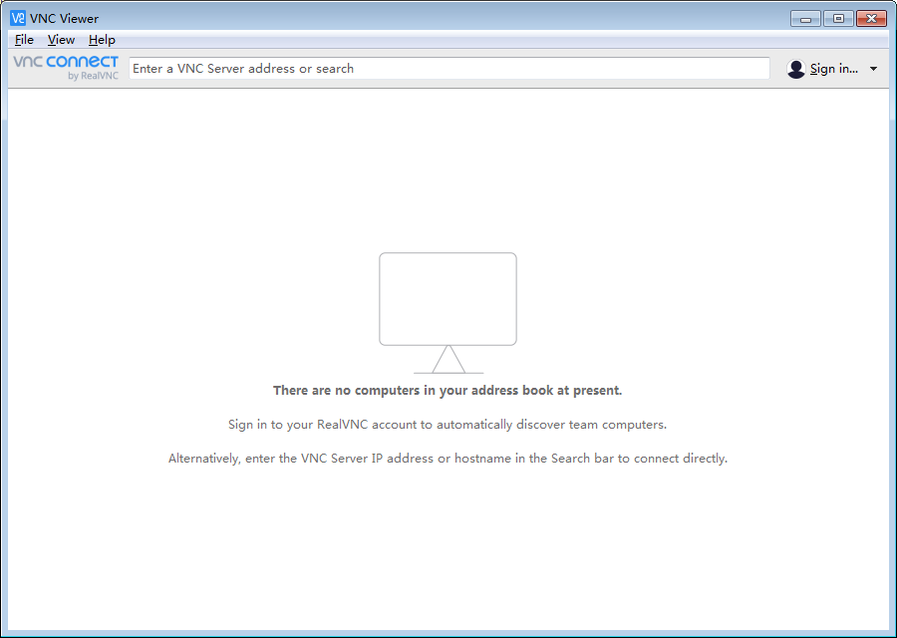 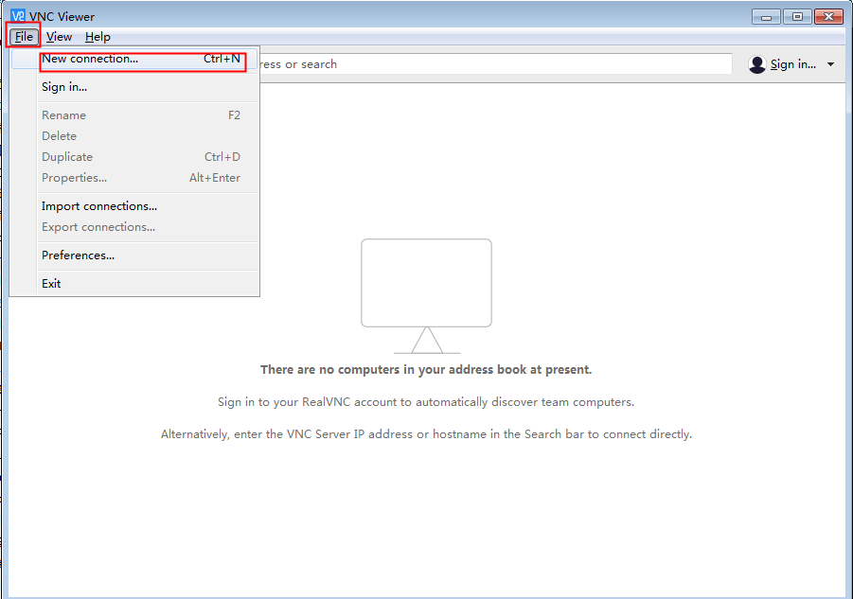

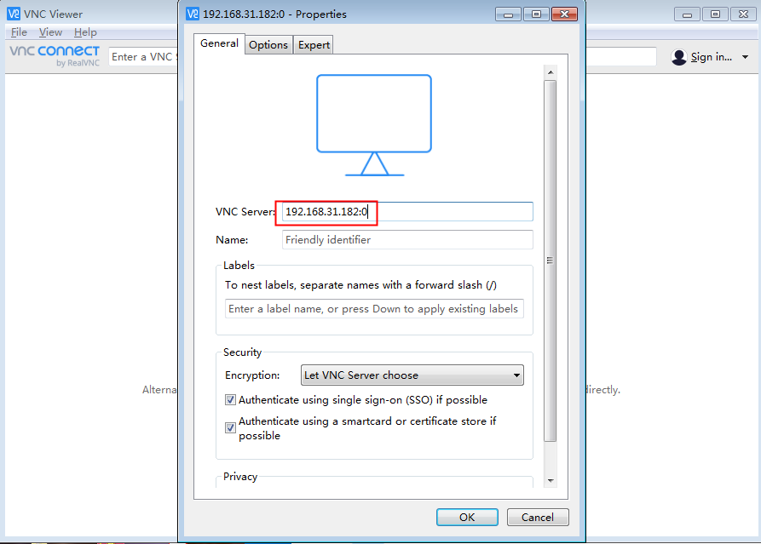 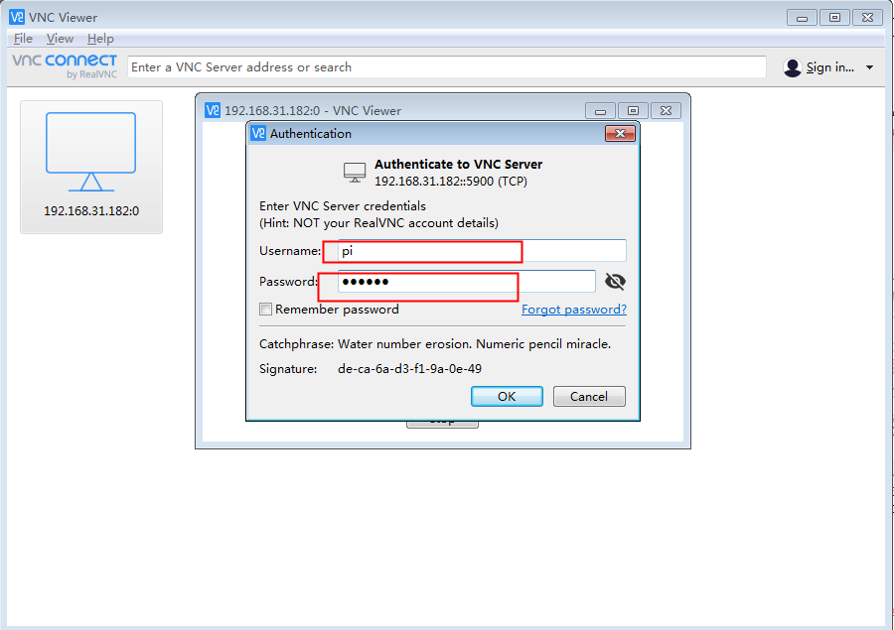

Figure 3.1.1 New VNC connection diagram

1. Open the Geany software, as shown in Figure 3.1.1

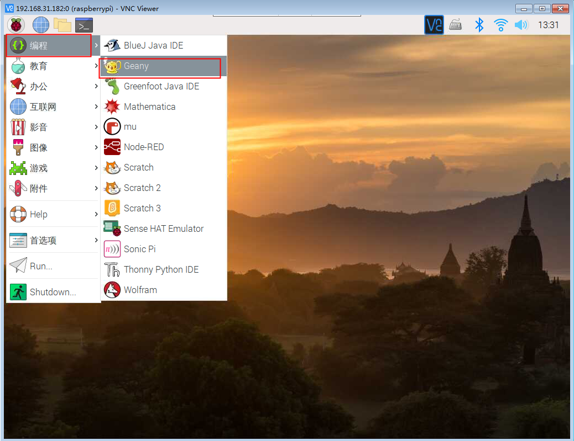

Figure 3.1.2 Geany software

1. Click "File-Ope

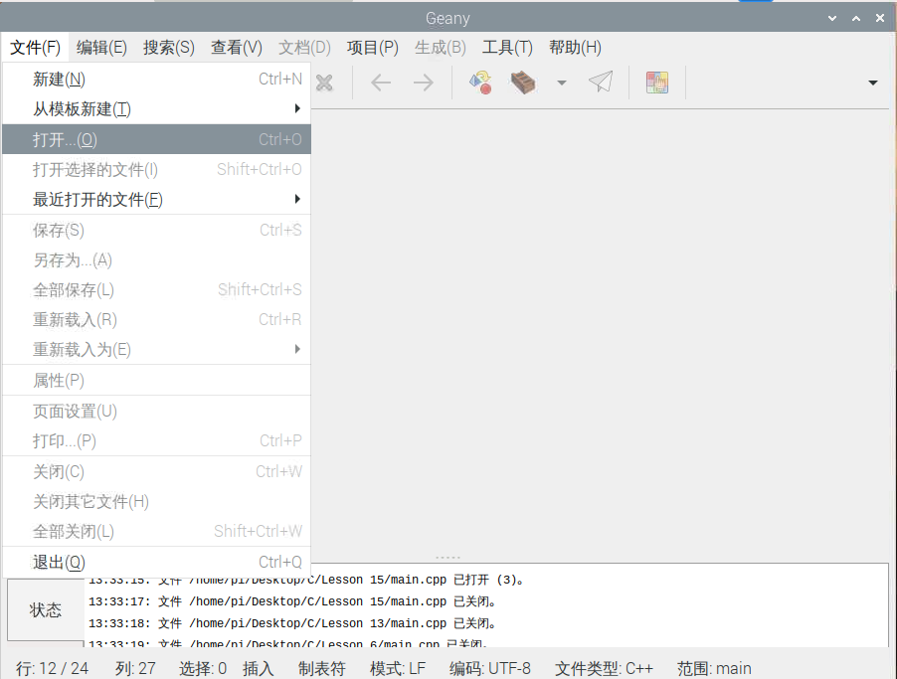

Figure 3.1.3 Programmer selection

1. Select the CPP file and open the program

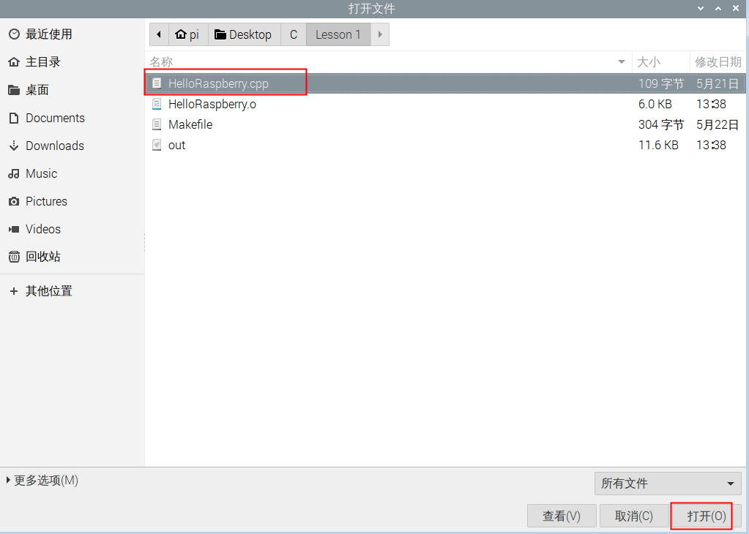

Figure 3.1.4 Open the program

1. Select build (B)-build (M) to show that the compilation is completed successfully. As shown in Figure 3.1.6

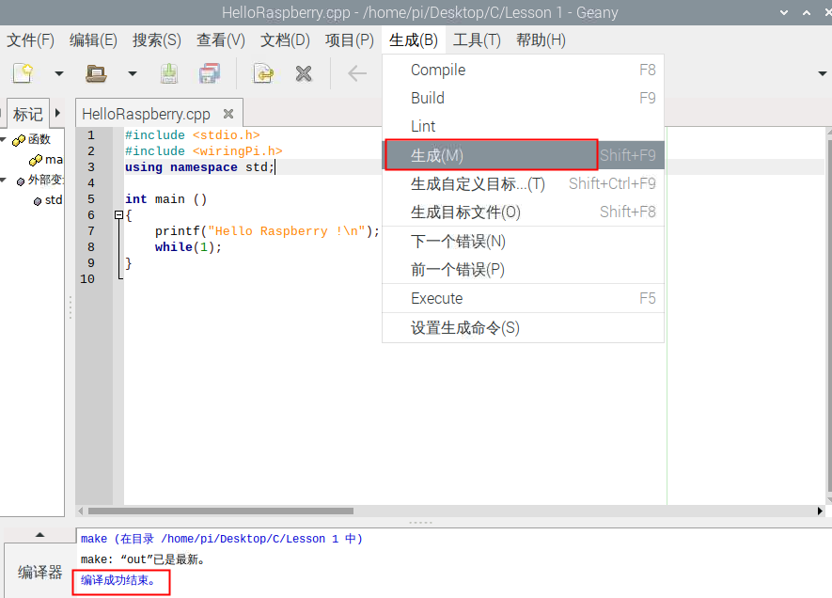

Figure 3.1.5 Compile to generate executable file

1. Find the out file in the file, double-click to run it, select Execute in the terminal emulator, and you will see the serial port continuously printing "Hello RaspberryPi!

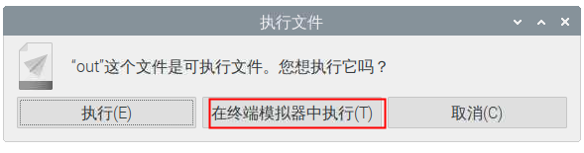

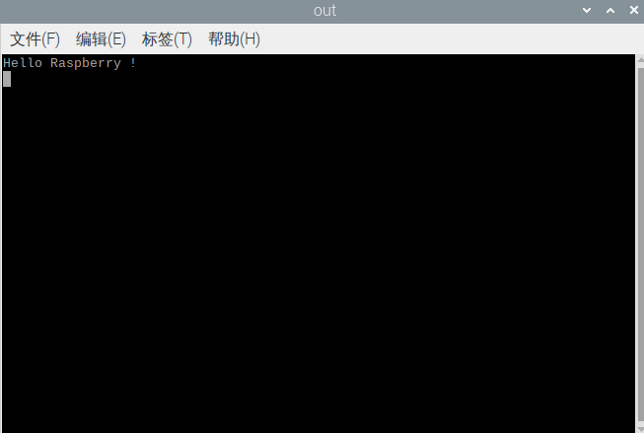

Figure 3.1.6 Terminal display

1. Open the Thonny Python IDE software, as shown in Figure 3.1.7

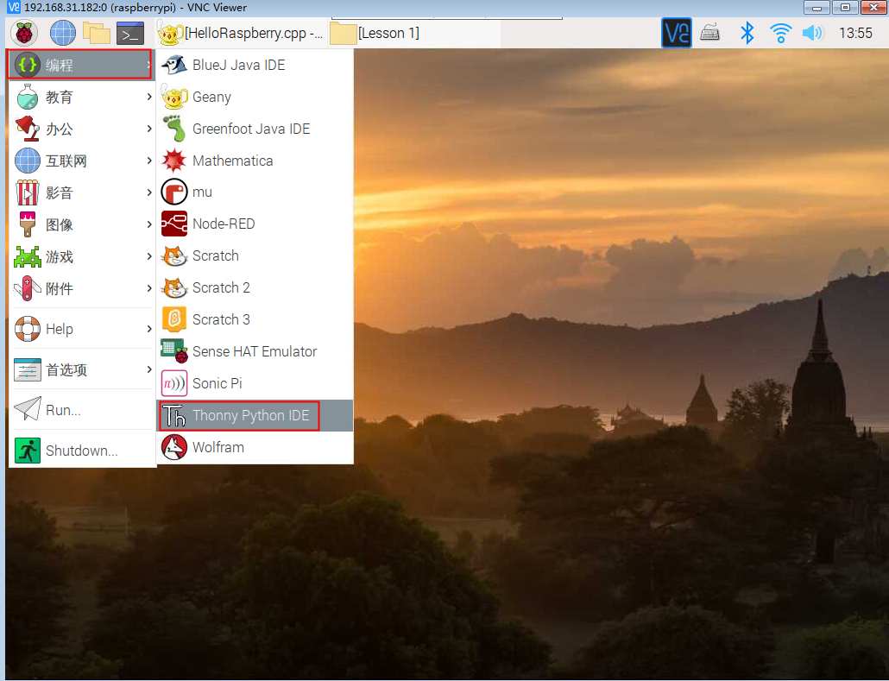

Figure 3.1.7 Thonny Python IDE software

1. Click "Load" to load the Python file

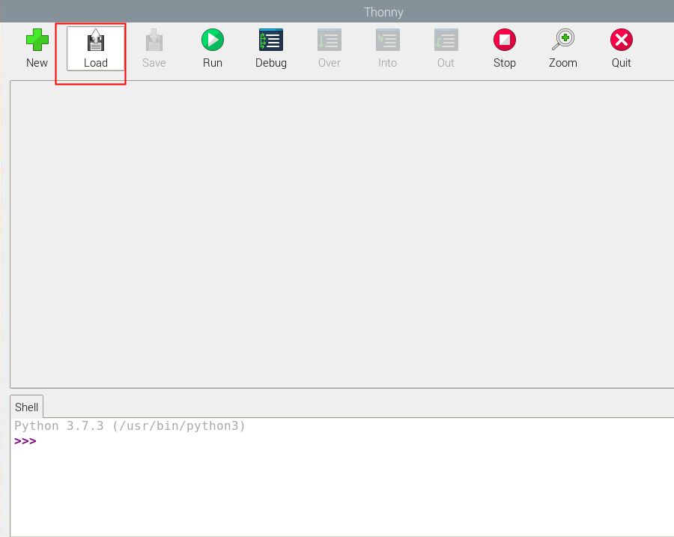

Figure 3.1.8 Programmer selection

1. Select the ".py" file and open the program

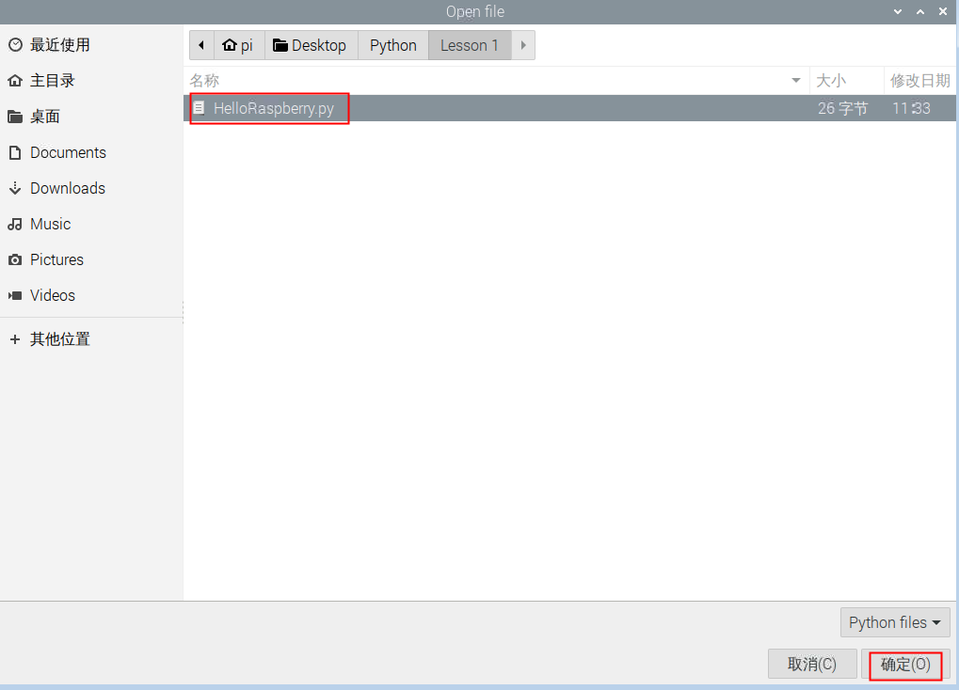

Figure 3.1.9 Open the program

1. Select Run, and see the running result in the Shell below. As shown in Figure 3.1.6

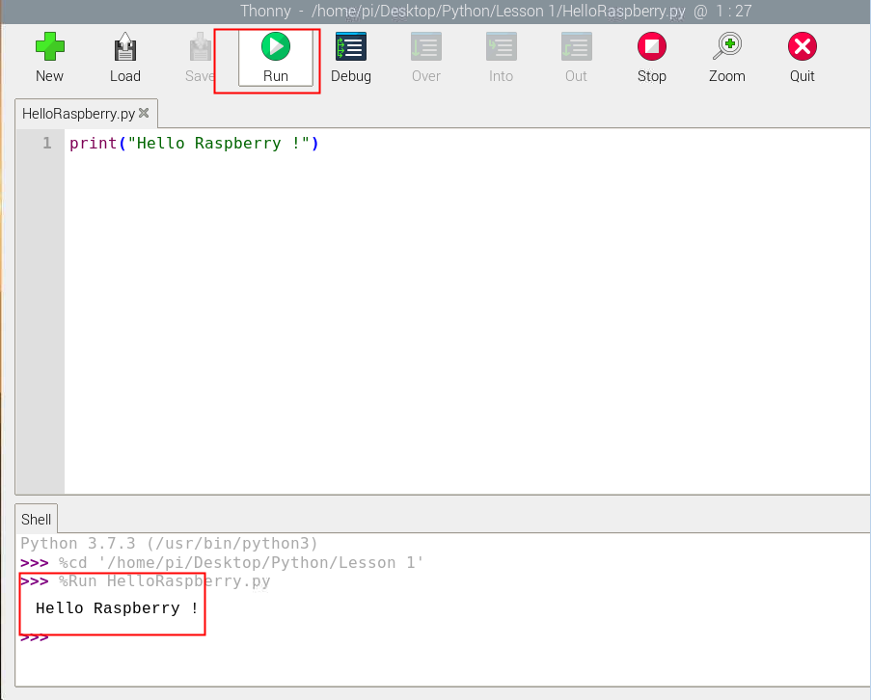

Figure 3.1.10 Run and display the result

1. Java environment construction:

Install JDK

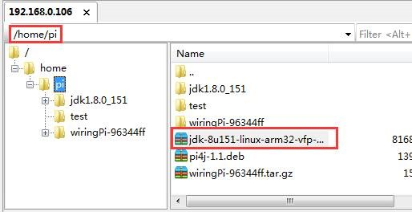

Enter on the command line (decompress the file to the current directory)：

**tar -zxvf jdk-8u151-linux-arm32-vfp-hflt.tar.gz**

Java environment variable configuration

Modify the configuration file:

Command line input: **sudo nano /etc/profile**

Add at the end of the file:

**JAVA_HOME=/home/pi/jdk1.8.0_151**

**CLASSPATH=.:$JAVA_HOME/jre/lib/rt.jar:$JAVA_HOME/lib/dt.jar:$JAVA_HOME/lib/tools.jar$**

**PATH=$JAVA_HOME/bin:$PATH**

**export JAVA_HOME CLASSPATH PATH**

Keyboard input: Ctrl+O, (Enter, Save) Ctrl+X, (Exit)

Command line input:source /etc/profile

1. Install pi4j

Terminal online installation:

Command：curl -s get.pi4j.com | sudo bash

1. Install wiringPi

Command：sudo apt-get purge wiringpi

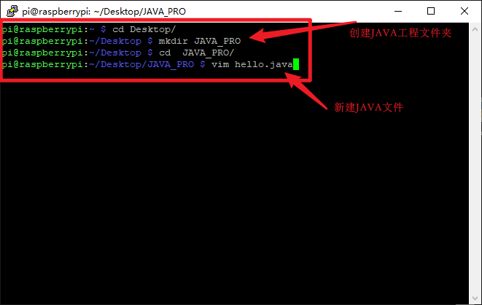

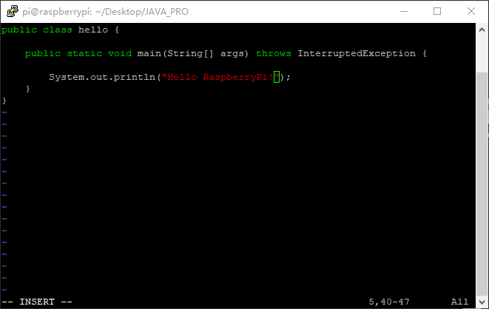

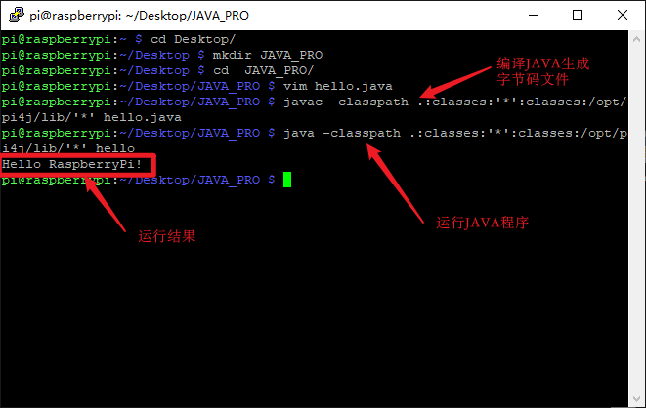

Compile and generate class file command:

javac -classpath .:classes:'*':classes:/opt/pi4j/lib/'*' XXX.java

Execute file command:

java -classpath .:classes:'*':classes:/opt/pi4j/lib/'*' XXX

**Experimental results：**

Use C++ to output Hello RaspberryPi through VNC programming software!

Use Python to output Hello RaspberryPi through Thonny Python IDE programming software!